APPLICATION FORM 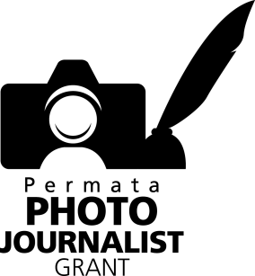

Permata Photojournalist Grant (PPG) Programme offers a scholarship for a 1-day-workshop by Martin Parr at Leica Activity Center in Jakarta on 13 January 2018.

Eligibility to apply for the scholarship is limited to:
- PPG Programme Alumni from the year 2011-2016 and TOT the year 2013-2017.
- Those who are able to speak English.
- Those who submit their application form and portfolio for selection.

APPLICATION
- Fill out in English and send the available application form along with your CV and latest headshot in digital format (3x4cm).
- Submit your portfolio which you will be bringing along for the workshop.
- Send your portfolio by following the guidelines below:
  - Up to 3 (three) photo stories on any subject of your own choice with a maximum of 12 photos (set at 72 dpi, 1200x8 pixels).
  - Attach the photographs in your email.
  - Name each photograph file with the photographer’s initial. For example: TO-Photo01, TO-Photo02 … in the order in which the photographs are arranged to suit the photo story.
  - Each photograph you send must be accompanied by a caption.
  - Include the text/story of the photo story you send us.
  - It is also possible to include a book proposal or photo book at PDF file within your portfolio.

SENDING THE APPLICATION
- Application forms can be submitted until 15 December 2017.
- Your application form, CV, latest headshot (in digital format) and portfolio should be sent to info@pannafoto.org
- The successful candidates will be announced on 22 December 2017.

SELECTION PROCESS
- The selection process will be conducted by PannaFoto Institute.
- The selection process will consider the candidates’ portfolios.
- The candidates’ English comprehension.

Please visit our website at www.permata-photojournalistgrant.org or contact :
Lisna at 0852 15565835 ( lisnaadwi@pannafoto.org) for further information.

Application Form
(please include this form with your portfolio)

PERSONAL INFORMATION

Full name :
Place / Date of Birth :
KTP ID Number :
Sex :
Telephone :
Email :
Home address :
Job :
Media :
Work Address :
English language proficiency (beginner, intermediate, advanced, fluent) :

- Why do you want to apply for this scholarship?

- How is this scholarship going to support you in your work?

I hereby declare my interest in joining the workshop, which is a part of PERMATA PHOTOJOURNALIST GRANT programme and I have also read and agreed to the rules and regulations which apply to this program.

Date (day/month/year)
Signature

